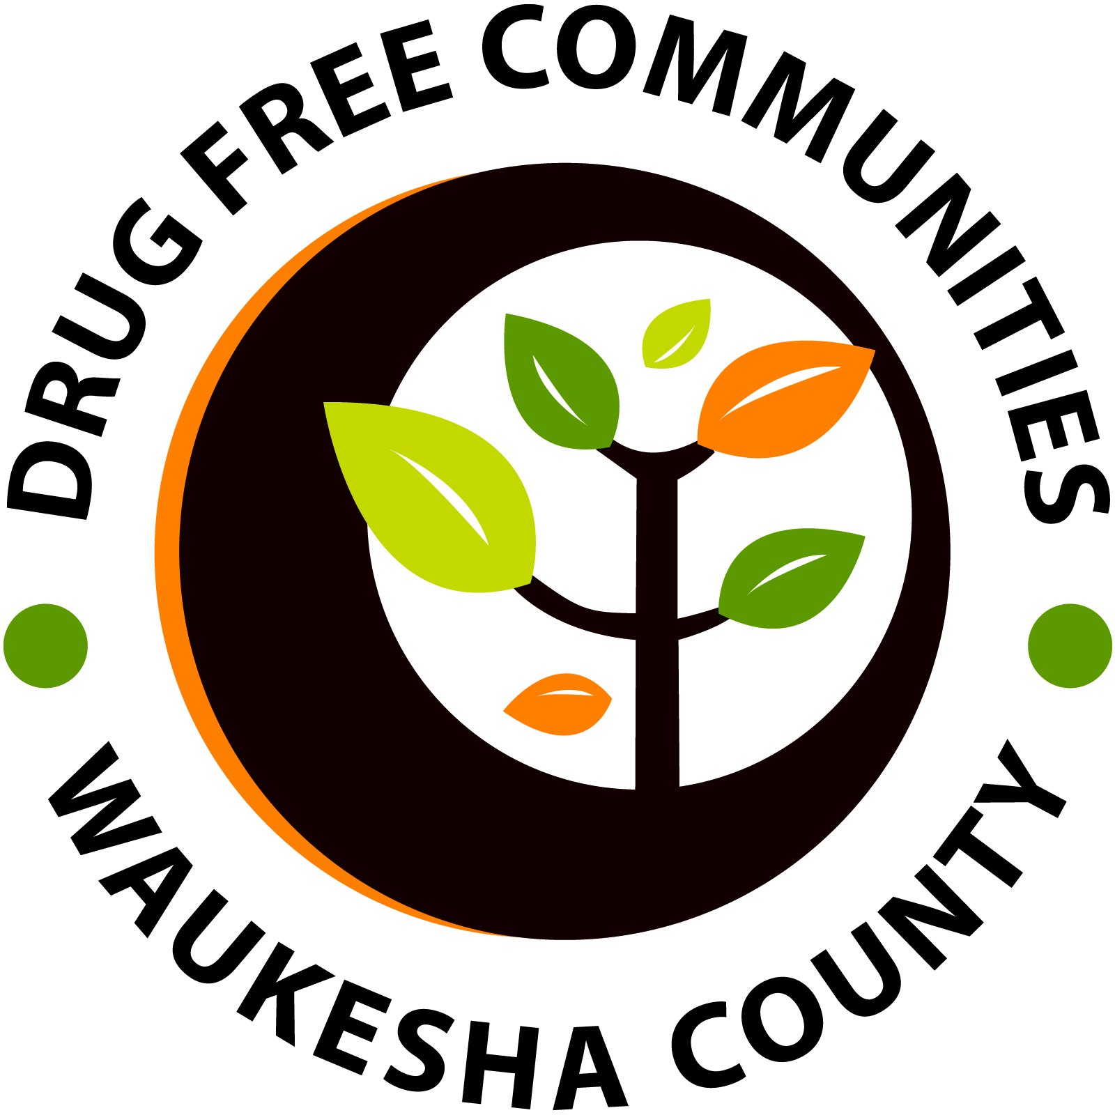

**PROGRAMS & MEDIA COMMITTEE MEETING AGENDA**

**Tuesday, February 27th, 2018 | 10:30am-12:00pm**

**Waukesha Memorial Hospital, Lobby Room #3**

Enter through the East Entrance. Turn right, towards the Café.

The room will be on your right past the restrooms.

1. Introductions and Review of Agenda [Adam Kindred; 10:30am-10:40am]
2. Youth Social Media Campaign and Video Competition [Adam Kindred; 10:40am-10:55am]
   1. Updates
   2. Finding more entrants
   3. Press / media coverage
3. 2018 National Prevention Week Event [Adam Kindred; 10:55am-11:30am]
   1. Calling the event- **Prevention in Action**
      1. Target Audience- Youth and Parents
      2. Secondary Audience- General Community
   2. The following is a **tentative schedule** for the night-
      1. 5:30 - 6 Resource Fair (small room maybe 10 tables)
      2. 6-6:30 Screen Prevention Videos (live voting at the event)
      3. 6:30 - 7:15 Rise Together Presentation
      4. 7:15 - 7:45 Panel with Rise Together, we could also grab a couple local stakeholders
      5. 7:45 - 8 Launch #DearFutureMe and Announce Video Competition Winners
      6. 8 - 8:30 More Resource Fair?
   3. Call to action
      1. Event Flyer and evite
      2. Resource Fair
      3. Additional Panel Members
      4. Outreach, Press / Media, possibly Paul Farrow declare it NPW
4. Other 2018 National Prevention Week Events and Activities (May 13th-19th)
   1. Sunday- Launch Parents Who Host Lose the Most
   2. Monday- Elevate WB Event
   3. Tuesday- Prevention in Action
   4. Wednesday- #DearFutureMe Challenge
   5. Thursday- #DearFutureMe Challenge
   6. Friday- DFC Coalition Meeting and Your Choice Fundraiser
   7. Saturday- SOFA Jump for Archie

**Next meeting: Tuesday, March 27th, 2018 from 10:30am-11:45pm.**

Stay connected, become our friend on Face Book – search [“@DFC Waukesha”](https://www.facebook.com/DFCWaukesha/)



and make our website a favorite [drugfreecommunitieswaukesha.com](http://drugfreecommunitywaukesha.com)

Questions or suggestions for the agenda, please contact: Adam Kindred, Program Coordinator, [akindred@elevateyou.org](mailto:akindred@elevateyou.org)

Waukesha County Drug Free Communities is a federally funded grant program under U.S. Department of Health & Human Services, Substance Abuse Mental Health Services Administration (SAMHSA) Grant # SP021397, overseen by Elevate, Inc.